TITLE OF WORK

by

First Name, Last Name

[Thesis/Dissertation/Project/Extended Essays] submitted in partial fulfillment of the requirements for the degree of

[MASTER OF…/DOCTOR OF …]
in
[CONCENTRATION]

UNIVERSITY OF PUERTO RICO
MAYAGÜEZ CAMPUS
[YEAR]

Approved by:
________________________________  Firstname Lastname, degree  President, Graduate Committee | __________________  Date
________________________________  Firstname Lastname, degree  Member, Graduate Committee | __________________  Date
________________________________  Firstname Lastname, degree  Member, Graduate Committee | __________________  Date
________________________________  Firstname Lastname, degree  Member, Graduate Committee | __________________  Date
________________________________  Firstname Lastname, degree  Representative of Graduate Studies | __________________  Date
________________________________  Firstname Lastname, degree  Chairperson of the Department | __________________  Date

Abstract
Abstract paragraphs should be unindented: use the style Body_Prelim.
Master’s abstracts are limited to 150 words; doctoral abstracts are limited to 350 words.
The use of keywords is optional, they may be placed below the abstract or on the next page.
You may include up to 5 keywords or phrases per language. Separate keywords with semicolons.
Keywords: UPRM template; thesis template; dissertation template; Microsoft Word
RESUMEN
El resumen es la traducción del Abstract. Use el estilo Body_Prelim. Para cambiar el lenguaje en esta sección, selecciónela con el cursor y escoja Tools>Language> Spanish.
Palabras clave: plantilla de UPRM; plantilla tesis; plantilla disertación; plantilla de Microsoft Word

Copyright (year) by (Name of Copyright Owner)
All Rights Reserved

Include your dedication here. This is optional, if you choose to not include a dedication delete this section. You can use the paragraph style of your liking.
Aquí puede incluir su dedicación. Esto es opcional, si no desea incluirla puede borrar esta sección. Si desea puede utilizar el estilo de párrafo de su selección.
Acknowledgments
This section is optional. Remember to acknowledge the correct institutions for any grants or seed money received.
Table of Contents
List of Tables vii
List of Figures viii
GLOSSARY OF TERMS ix
List of Appendices x
Chapter 1 Introduction 1
Chapter 2 Literature Review 2
2.1 [Subheading Level 2] 2
Chapter 3 Methodology 3
3.1 [Subheading Level 2] 3
3.2 [Subheading Level 2] 4
Chapter 4 Results 5
4.1 [Subheading Level 2] 5
4.1.1 [Subheading level 3] 5
4.1.1.1 [Subheading Level 4] 5
Chapter 5 Conclusion 7
References 8

List of Tables
Table 4.1 Example of a table 5
Table 4.2 Example of landscape table 6

List of Figures
Figure 3.1 Example of a figure. 4

GLOSSARY OF TERMS
A flow area
a, b coefficients in the radar rain rate equation
AMS Annual Maximum Series
ArcGIS Arc Geographical Information Systems
ASCII data file in text format
Bias bias
C Celsius

List of Appendices
Appendix A 9
Appendix B 10
Appendix C 11

Introduction
This template’s purpose is to help ease the process of redacting your thesis/dissertation. Working with this template can save you time and will help you create a professional looking thesis with the least amount of formatting mistakes. We recommend you use the show editing symbols as this facilitates editing your work, select the ¶ symbol in the Home ribbon.
The template also includes a Table of Contents, List of Tables, List of Figures, and List of Appendices that can be updated in a second! Just right-click anywhere and select Update fields>Update Entire Table. Remember to use Help on the Word® Menu if you have questions.
It is also suggested that academic works be written in English to reach a wider audience. Remember that sentences in English are often shorter than in Spanish, so do not translate directly. To change the language on Microsoft Word choose Tools>Language…>English(US). If you need any assistance with writing your thesis in English, you can contact the Graduate Writing Facilitators (GWFs). For more information on the services that the GWFs provide visit https://libguides.uprm.edu/writingclinics.
To cross reference a figure, table, equation, etc. in your text, choose Insert>Cross-reference… and on “Reference Type” choose Figure, Table, or Equation. Then on “Insert Reference to:” choose only Label and Number. To update ALL fields within the document do control-A (command-A for mac), then right-click and Update Field.
. We wish you success!

Literature Review
Remember to use the correct styles when writing. To do so click on the desired style on the Home ribbon. Lorem ipsum dolor sit amet, consectetur adipiscing elit. Nam dignissim dui purus. Quisque non lobortis ex, et sollicitudin risus. Praesent odio metus, ornare vel sapien sed, efficitur sagittis dui. Morbi suscipit orci ex, vel bibendum erat lacinia nec. Ut orci nibh, fringilla nec erat ac, cursus porttitor sapien.

[Subheading Level 2]
Lorem ipsum dolor sit amet, consectetur adipiscing elit. Nam dignissim dui purus. Quisque non lobortis ex, et sollicitudin risus. Praesent odio metus, ornare vel sapien sed, efficitur sagittis dui. Morbi suscipit orci ex, vel bibendum erat lacinia nec. Ut orci nibh, fringilla nec erat ac, cursus porttitor sapien.
Curabitur eu quam at quam tempus dapibus in ac metus. Donec vulputate elit sem, ac varius diam sagittis eget. Phasellus commodo ornare consequat. Integer porttitor eros quis vehicula aliquet. Etiam tempor, purus ut porttitor scelerisque, felis lacus porttitor ante, ornare ultricies diam mauris et risus. Donec aliquet, enim non tincidunt lacinia, massa sapien finibus mauris, eu fringilla leo turpis quis ante.
Duis rhoncus leo in nisi euismod, eu malesuada erat facilisis. Interdum et malesuada fames ac ante ipsum primis in faucibus. Suspendisse nec magna at dui consectetur congue. Nunc malesuada bibendum nisi vel vehicula. Sed libero nulla, viverra eu nulla nec, scelerisque euismod lectus. Nullam eget bibendum sapien, in euismod enim. Curabitur dui turpis, ultrices in commodo id, ornare eu sapien. Nulla pharetra nunc elit, sit amet ultricies nibh condimentum at.

Methodology
Lorem ipsum dolor sit amet, consectetur adipiscing elit. Nam dignissim dui purus. Quisque non lobortis ex, et sollicitudin risus. Praesent odio metus, ornare vel sapien sed, efficitur sagittis dui. Morbi suscipit orci ex, vel bibendum erat lacinia nec. Ut orci nibh, fringilla nec erat ac, cursus porttitor sapien. Curabitur accumsan auctor justo.

[Subheading Level 2]
Lorem ipsum dolor sit amet, consectetur adipiscing elit. Nam dignissim dui purus. Quisque non lobortis ex, et sollicitudin risus. Praesent odio metus, ornare vel sapien sed, efficitur sagittis dui. Morbi suscipit orci ex, vel bibendum erat lacinia nec. Ut orci nibh, fringilla nec erat ac, cursus porttitor sapien. Curabitur accumsan auctor justo.
Lorem ipsum dolor sit amet, consectetur adipiscing elit. Nam dignissim dui purus. Quisque non lobortis ex, et sollicitudin risus. Praesent odio metus, ornare vel sapien sed, efficitur sagittis dui. Morbi suscipit orci ex, vel bibendum erat lacinia nec. Ut orci nibh, fringilla nec erat ac, cursus porttitor sapien. Curabitur accumsan auctor justo.
This is an example of an equation:

Equation 3.1
$$A=πr^{2}$$

This is an example of cross referencing an equation, see Equation 3.1 Lorem ipsum dolor sit amet, consectetur adipiscing elit. Nam dignissim dui purus. Quisque non lobortis ex, et sollicitudin risus. Praesent odio metus, ornare vel sapien sed, efficitur sagittis dui. Morbi suscipit orci ex, vel bibendum erat lacinia nec. Ut orci nibh, fringilla nec erat ac, cursus porttitor sapien. Curabitur accumsan auctor justo.

[Subheading Level 2]
Lorem ipsum dolor sit amet, consectetur adipiscing elit. Nam dignissim dui purus. Quisque non lobortis ex, et sollicitudin risus. Praesent odio metus, ornare vel sapien sed, efficitur sagittis dui. Morbi suscipit orci ex, vel bibendum erat lacinia nec. Ut orci nibh, fringilla nec erat ac, cursus porttitor sapien. Curabitur accumsan auctor justo.
This is an example of a cross referenced image, see Figure 3-1.
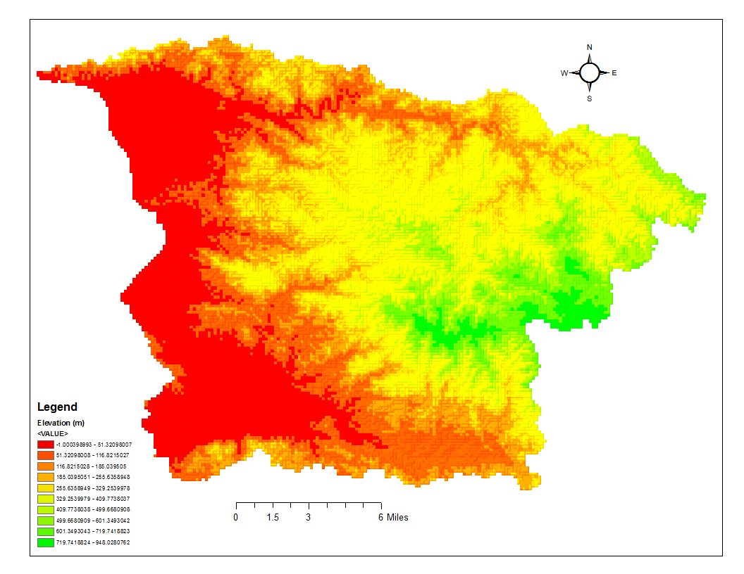
Figure 3.1 Example of a figure.

Results
Lorem ipsum dolor sit amet, consectetur adipiscing elit. Nam dignissim dui purus. Quisque non lobortis ex, et sollicitudin risus. Praesent odio metus, ornare vel sapien sed, efficitur sagittis dui. Morbi suscipit orci ex, vel bibendum erat lacinia nec.

[Subheading Level 2]
This is an example of a table, see Table 1.
Table 4.1 Example of a table
 | West | East | North | South
Count | 1 | 7 | 0 | 32

[Subheading level 3]
Lorem ipsum dolor sit amet, consectetur adipiscing elit. Nam dignissim dui purus. Quisque non lobortis ex, et sollicitudin risus. Praesent odio metus, ornare vel sapien sed, efficitur sagittis dui. Morbi suscipit orci ex, vel bibendum erat lacinia nec. Ut orci nibh, fringilla nec erat ac, cursus porttitor sapien. Curabitur accumsan auctor justo.

[Subheading Level 4]
Lorem ipsum dolor sit amet, consectetur adipiscing elit. Nam dignissim dui purus. Quisque non lobortis ex, et sollicitudin risus. Praesent odio metus, ornare vel sapien sed, efficitur sagittis dui. Morbi suscipit orci ex, vel bibendum erat lacinia nec. Ut orci nibh, fringilla nec erat ac, cursus porttitor sapien. Curabitur accumsan auctor justo.

Lorem ipsum dolor sit amet, consectetur adipiscing elit. Nam dignissim dui purus. Quisque non lobortis ex, et sollicitudin risus. Praesent odio metus, ornare vel sapien sed, efficitur sagittis dui. Morbi suscipit orci ex, vel bibendum erat lacinia nec. Ut orci nibh, fringilla nec erat ac, cursus porttitor sapien. Curabitur accumsan auctor justo.
This is an example of a table on landscape orientation. You can do this with any table you wish. Just add section breaks before and after the table by using Layout > Breaks. Use a Next Page Section Break before the desired content and a Continous Section Break after. Then select the content and change the page orientation to landscape using Layout > Orientation > Landscape.
Table 4.2 Example of landscape table
Locations | Májimo | Isla Cueva | Desecheo | Mona | Caja de Muertos | Gilligans | Vieques | Culebra | Palomino
Visited | Yes | Yes | Yes | No | Yes | Yes | Yes | No | no
Samples collected | 19 | 12 | 17 | 0 | 18 | 22 | 20 | 0 | 0

Conclusion
Lorem ipsum dolor sit amet, consectetur adipiscing elit. Nam dignissim dui purus. Quisque non lobortis ex, et sollicitudin risus. Praesent odio metus, ornare vel sapien sed, efficitur sagittis dui. Morbi suscipit orci ex, vel bibendum erat lacinia nec. Ut orci nibh, fringilla nec erat ac, cursus porttitor sapien. Curabitur accumsan auctor justo. Vivamus finibus odio mauris, ut lobortis mauris mollis sed.
Curabitur eu quam at quam tempus dapibus in ac metus. Donec vulputate elit sem, ac varius diam sagittis eget. Phasellus commodo ornare consequat. Integer porttitor eros quis vehicula aliquet. Etiam tempor, purus ut porttitor scelerisque, felis lacus porttitor ante, ornare ultricies diam mauris et risus. Donec aliquet, enim non tincidunt lacinia, massa sapien finibus mauris, eu fringilla leo turpis quis ante. Vestibulum velit nulla, eleifend a elit semper, rhoncus elementum justo. Orci varius natoque penatibus et magnis dis parturient montes, nascetur ridiculus mus.
Duis rhoncus leo in nisi euismod, eu malesuada erat facilisis. Interdum et malesuada fames ac ante ipsum primis in faucibus. Suspendisse nec magna at dui consectetur congue. Nunc malesuada bibendum nisi vel vehicula. Sed libero nulla, viverra eu nulla nec, scelerisque euismod lectus. Nullam eget bibendum sapien, in euismod enim. Curabitur dui turpis, ultrices in commodo id, ornare eu sapien. Nulla pharetra nunc elit, sit amet ultricies nibh condimentum at.

References
It is highly recommended that you use a reference manager. This will reduce mistakes while creating citations and the bibliography. It is also a great way to save time.

Lorem ipsum dolor sit amet, consectetur adipiscing elit. Nam dignissim dui purus. Quisque non lobortis ex, et sollicitudin risus. Praesent odio metus, ornare vel sapien sed, efficitur sagittis dui. Morbi suscipit orci ex, vel bibendum erat lacinia nec. Ut orci nibh, fringilla nec erat ac, cursus porttitor sapien. Curabitur accumsan auctor justo. Vivamus finibus odio mauris, ut lobortis mauris mollis sed.
Curabitur eu quam at quam tempus dapibus in ac metus. Donec vulputate elit sem, ac varius diam sagittis eget. Phasellus commodo ornare consequat. Integer porttitor eros quis vehicula aliquet. Etiam tempor, purus ut porttitor scelerisque, felis lacus porttitor ante, ornare ultricies diam mauris et risus. Donec aliquet, enim non tincidunt lacinia, massa sapien finibus mauris, eu fringilla leo turpis quis ante. Vestibulum velit nulla, eleifend a elit semper, rhoncus elementum justo. Orci varius natoque penatibus et magnis dis parturient montes, nascetur ridiculus mus.
Duis rhoncus leo in nisi euismod, eu malesuada erat facilisis. Interdum et malesuada fames ac ante ipsum primis in faucibus. Suspendisse nec magna at dui consectetur congue. Nunc malesuada bibendum nisi vel vehicula. Sed libero nulla, viverra eu nulla nec, scelerisque euismod lectus. Nullam eget bibendum sapien, in euismod enim. Curabitur dui turpis, ultrices in commodo id, ornare eu sapien. Nulla pharetra nunc elit, sit amet ultricies nibh condimentum at.

Lorem ipsum dolor sit amet, consectetur adipiscing elit. Nam dignissim dui purus. Quisque non lobortis ex, et sollicitudin risus. Praesent odio metus, ornare vel sapien sed, efficitur sagittis dui. Morbi suscipit orci ex, vel bibendum erat lacinia nec. Ut orci nibh, fringilla nec erat ac, cursus porttitor sapien. Curabitur accumsan auctor justo. Vivamus finibus odio mauris, ut lobortis mauris mollis sed.
Curabitur eu quam at quam tempus dapibus in ac metus. Donec vulputate elit sem, ac varius diam sagittis eget. Phasellus commodo ornare consequat. Integer porttitor eros quis vehicula aliquet. Etiam tempor, purus ut porttitor scelerisque, felis lacus porttitor ante, ornare ultricies diam mauris et risus. Donec aliquet, enim non tincidunt lacinia, massa sapien finibus mauris, eu fringilla leo turpis quis ante. Vestibulum velit nulla, eleifend a elit semper, rhoncus elementum justo. Orci varius natoque penatibus et magnis dis parturient montes, nascetur ridiculus mus.
Duis rhoncus leo in nisi euismod, eu malesuada erat facilisis. Interdum et malesuada fames ac ante ipsum primis in faucibus. Suspendisse nec magna at dui consectetur congue. Nunc malesuada bibendum nisi vel vehicula. Sed libero nulla, viverra eu nulla nec, scelerisque euismod lectus. Nullam eget bibendum sapien, in euismod enim. Curabitur dui turpis, ultrices in commodo id, ornare eu sapien. Nulla pharetra nunc elit, sit amet ultricies nibh condimentum at.

Lorem ipsum dolor sit amet, consectetur adipiscing elit. Nam dignissim dui purus. Quisque non lobortis ex, et sollicitudin risus. Praesent odio metus, ornare vel sapien sed, efficitur sagittis dui. Morbi suscipit orci ex, vel bibendum erat lacinia nec. Ut orci nibh, fringilla nec erat ac, cursus porttitor sapien. Curabitur accumsan auctor justo. Vivamus finibus odio mauris, ut lobortis mauris mollis sed.
Curabitur eu quam at quam tempus dapibus in ac metus. Donec vulputate elit sem, ac varius diam sagittis eget. Phasellus commodo ornare consequat. Integer porttitor eros quis vehicula aliquet. Etiam tempor, purus ut porttitor scelerisque, felis lacus porttitor ante, ornare ultricies diam mauris et risus. Donec aliquet, enim non tincidunt lacinia, massa sapien finibus mauris, eu fringilla leo turpis quis ante. Vestibulum velit nulla, eleifend a elit semper, rhoncus elementum justo. Orci varius natoque penatibus et magnis dis parturient montes, nascetur ridiculus mus.
Duis rhoncus leo in nisi euismod, eu malesuada erat facilisis. Interdum et malesuada fames ac ante ipsum primis in faucibus. Suspendisse nec magna at dui consectetur congue. Nunc malesuada bibendum nisi vel vehicula. Sed libero nulla, viverra eu nulla nec, scelerisque euismod lectus. Nullam eget bibendum sapien, in euismod enim. Curabitur dui turpis, ultrices in commodo id, ornare eu sapien. Nulla pharetra nunc elit, sit amet ultricies nibh condimentum at.

